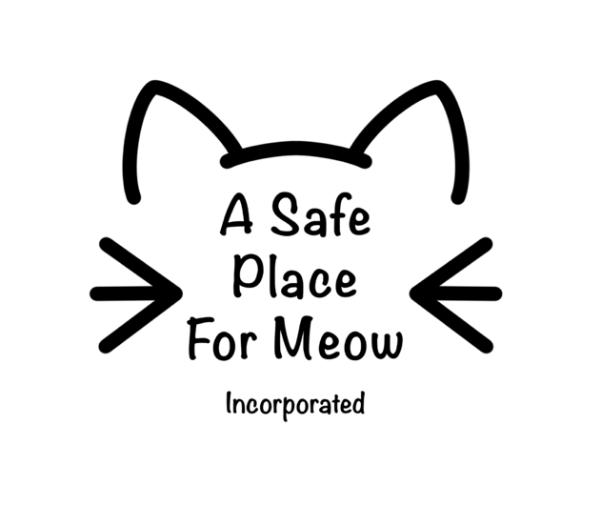
Adoption
APPLICATION FORM

- Contact Information
Name:
Phone Number:
Email:
What is your preferred method of contact?
Date of Birth:
Drivers Licence Number:
Residential address:

Postal address:

Alternative Contact Name:
Alternative Contact Number:
Address where cat/kitten will be cared for:

- Cat you would like to adopt
Cat’s Name:

Have you met this cat before? | Yes /No
If not, what dates/times work for you to arrange a meet and greet?

Who are you adopting the cat for/ why would you like to adopt a cat/kitten?

Which areas of the house / yard will the cat have access to?
E.g. secure cat proof backyard, laundry and kitchen.

Will the cat be allowed outside? How often?
E.g. never, in evening, when someone is home, all the time, only on a harness when going on a daily walk

Where will the cat sleep?
How many hours will the cat be without human company during the day?
What do you believe a cat needs to be happy, healthy, & safe?

- Previous Experience
Have you owned cats/kittens before? | Yes / No
If yes, what happened to them?

Have you every surrendered/rehomed an animal before? | Yes /No
If yes, please provide details

Have you ever been investigated or charged with an animal welfare offense? | Yes / No
If yes, please provide details

- Current Situation
Do you currently have any pets at the above address? |  |  |  |  | Yes / No
If yes, please provide details below:
Name:  Age: | Species: | Vaccination and pest prevention up to date | Yes /No | De-sexed | Yes/No
Name:  Age: | Species: | Vaccination and pest prevention up to date | Yes /No | De-sexed | Yes/No
Name:  Age: | Species: | Vaccination and pest prevention up to date | Yes /No | De-sexed | Yes/No
Name:  Age: | Species: | Vaccination and pest prevention up to date | Yes /No | De-sexed | Yes/No
Where do your current pets sleep?
Who is your current veterinarian clinic?
Phone Number:
May we contact for a reference? |  |  |  |  | Yes / No
Including yourself, how many people live in your household?
Is anyone in your household allergic to cats? |  |  |  |  | Yes / No
Do you have permission from your landlord to keep this animal in your home? |  |  |  |  | Yes / No
If renting, please provide details so that this can be verified
Property Manager/Real Estate or Landlord:
Ph:
Do you have children? If yes, what ages?
When you go on holiday, who looks after your pets?
E.g. Trusted friend/family, cattery, other

Under what circumstances would you give up a pet?

Is there anything else you would like to tell us about you, or your family, or your interest in adopting this cat?

Terms and Conditions:
- I am willing and prepared to take responsibility for this cat for the duration of its lifetime (10 – 20+ years)
- I understand that this is an application only and that I will be notified of the outcome within 2 business days.
- I understand that if my application for adoption is approved, I am able and willing to pay the full adoption fee within 2 working days of written notification
- I understand that the age and breed of A Safe Place for Meow cats/kittens is generally an estimate and is accurate to the best of their knowledge only.
- I agree to ensure all outstanding vet work is completed promptly and kept up to date for the remainder of the cats life.
- I agree and understand that animals from A Safe Place for Meow have undergone a full health check from a veterinarian before being placed for adoption, and that I have been made aware of any medical conditions that the animal I wish to adopt currently has (if any).
- From the approval of the adoption forward I agree that I am responsible for any and all veterinary bills accrued in relation to the cat listed on this application form, and that A Safe Place for Meow will not be held liable for any further medical expenses.
- I agree that A Safe Place for Meow has disclosed, to the best of their knowledge, any behavioural issues this animal displayed prior to adoption (if any) and that I adopt at my own risk. I release A Safe Place for Meow and related individual and entities from any and all liability or damages related to person(s) and/or property caused by the animal listed on this adoption application.
- I agree that if any behaviour concerns emerge with this cat in the future I will contact A Safe Place for Meow and work with them to attempt to resolve prior to either surrender or euthanasia.
- If for reasons outside my control I can no longer care for the animal I will contact A Safe Place for Meow to discuss options.
- I undertake to give up the animal to the lawful owner should such an owner be discovered within 2 weeks of the adoption date. In that event, A Safe Place for Meow will provide a refund.
- I undertake that the animal will not: a) Be used for experimental or research purposes of any description; and/or b) Be used for any business or security related purpose; and/or
c) Be offered for resale; and/or
d) Be used for dog fighting and/or
e) Be used for hunting
- I agree to abide by all local council guidelines relating to keeping a cat including registration if required.
- I can certify that the answers in this application are complete, true and not misleading in any way. I am authorizing you to contact landlords, associations and veterinarians as required to validate or to conduct a home assessment.

I (your name) understand and agree that the cat/s or kitten/s I am submitting the adoption application for will strictly be indoor car/s or kitten/s only. I understand if I do not comply with this and A Safe Place For Meow has been advised or has suspicion that the cat/s or kitten/s are not indoor animals only and/or the animal is in breach of any or all animal welfare, or feel the animal is not being treated fairly they are permitted to terminate the adoption application at any given point without refund and taking the suspected cat/s or kitten/s into custody.

I (your name) understand and agree that the cat/s or kitten/s I am submitting this adoption application may not have had all veterinary work completed prior to adoption (due to young age or otherwise). Due dates for any outstanding veterinary work (which only includes surgical sterilisation, vaccination and/or microchip) will be provided to me in an adoption approval document. The veterinary work stated above will be included in the adoption fee only at the selected veterinary clinics stated in the adoption approval documents. I understand if I do not comply with this, A Safe Place For Meow has the right to take custody of the adopted cat/s or kitten/s due to breach of contract and adoption fee forfeited. I understand that if veterinary work is not completed within 4 weeks of the due date, the veterinary work included within the adoption fee will be forfeited and I will have to pay for any outstanding veterinary work myself.

Signature Date / / 20 .

I accept / I do not accept

Signature Date / / 20 .

To submit your application, please send this form and a copy of your valid licence, Proof of ID or Passport to asafeplaceformeow@outlook.com.au; alternatively you can submit these to a member of A Safe Place For Meow.

*BANK DETAILS*
*At this stage we can only offer payment via direct debit*
*BANK DETAILS*
Name: A SAFE PLACE FOR MEOW
BSB: 015891
ACCOUNT NUMBER: 152276815
Reference: *Cat/Kitten Name*

You can also find us on

@ a_safe_place_for_meow
***A Safe Place for Meow reserves the right to refuse any application without providing any information as to why the application was declined***
Official Use Only

Application Approved | Application declined  Reason:
Coordinator Name:
Signature: | Date:

