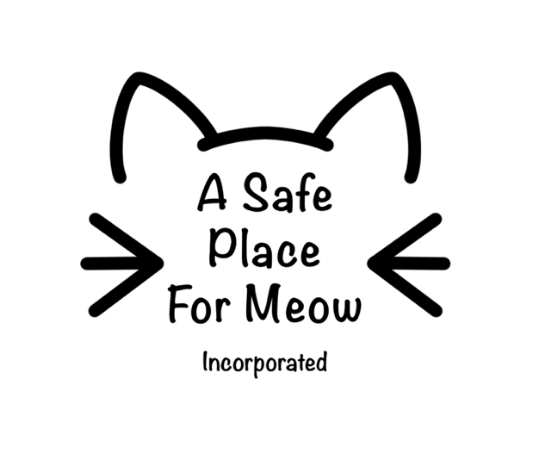
Foster Carer
APPLICATION FORM

***ALL FOSTER CATS/KITTENS ARE TO BE INSIDE CATS ONLY***

- Contact Information
Name:
Phone Number:
Email:
What is your preferred method of contact?
Date of Birth:
Drivers Licence Number:
Alternative Contact Name:
Alternative Contact Number:
Address where cat/kitten will be cared for:

- Type of Foster
I am willing and able to foster the following:
 | Bottle fed kittens (0-8 weeks) *Previous experience required* |  | Kittens (8-16 weeks)
 | Adult cat |  | Pregnant cats/Mother cats with litter
 | Cats with illness/special needs (cat flu, ringworm, etc.)
**please note cats and kittens are generally fostered in pairs. Please advise if you are only able to foster 1 (one) cat/kitten**
- Previous Experience
Have you had previous experience with the type of cats you are willing to foster? | Yes / No
If yes, please provide a short summary:
Example: Once cared for litter of bottle babies from 3 days old to 6wks old, feeds every two hours in the first week, weaned onto solids around 4-5wks old.

If no, would you be interested in training or assistance? If yes, we will be in contact to discuss options. | Yes /No
Have you fostered animals before? | Yes / No
If yes, what organisation did you foster through?
May we contact for a reference? | Yes / No

- Current Situation
Do you currently have any pets at the above address? |  |  |  |  | Yes / No
If yes, please provide details below:
Name:  Age: | Species: | Vaccination and pest prevention up to date | Yes /No | De-sexed | Yes/No
Name:  Age: | Species: | Vaccination and pest prevention up to date | Yes /No | De-sexed | Yes/No
Name:  Age: | Species: | Vaccination and pest prevention up to date | Yes /No | De-sexed | Yes/No
Name:  Age: | Species: | Vaccination and pest prevention up to date | Yes /No | De-sexed | Yes/No
Who is your current veterinarian clinic?
Phone Number:
May we contact for a reference? |  |  |  |  | Yes / No
Including yourself, how many people live in your household?
Is anyone in your household allergic to cats? |  |  |  |  | Yes / No
Do you have permission from your landlord to keep this animal in your home? |  |  |  |  | Yes / No
Do you have children? If yes, what age?

Terms and Conditions:
- I will provide my foster animals with a safe environment including shelter, security, food, water, and appropriate environmental enrichment and socialisation.
- I understand that A Safe Place for Meow runs on donations and may not always be able to provide food and litter supplies to foster carers.
- I will ensure parasite prevention is administered as required and recorded, and that this will be provided by a Safe Place for Meow.
- I have the permits, where required by local government, to keep the number of animals at the premises.
- I understand that where possible, A Safe Place for Meow undertake temperament assessments of cats/kittens before placing with foster carers and will disclose to the best of their knowledge any behavioural issues the cat may have displayed prior to foster (if any). Due to the nature of the organisation however, a behaviour assessment prior to foster is not always possible and in both cases I understand that I foster at my own risk. Furthermore, I release A Safe Place for Meow and related individuals and entities from any and all liability or damages to person(s) and or property caused by the animals I foster.
- I will not foster animals from any other rehoming groups to prevent cross-contamination
- I will notify one the coordinators ASAP should I find I am no longer able to care for my foster animal.
- I will notify one of the coordinators immediately and present the animal to the vet clinic nominated by the coordinator if symptoms of illness/injury develop.
- I understand that while A Safe Place for Meow values their foster carers efforts and opinions, that I do not own my foster animal/s and that decisions regarding my foster animal’s care and management reside with A Safe Place for Meow.
- If I arrange medical treatment without first contacting A Safe Place for Meow, I understand that I will not be reimbursed for these expenses.
- I will follow any veterinary instructions on medication or treatment regimes as directed by a veterinary practitioner for foster animals in my care.
- I will not allow foster cats in my care to leave the nominated premises, nor will I pass care over to another person without authorisation from A Safe Place for Meow.
- I will ensure that cats or kittens leaving the premises are in a crate, or secure carrier.
- I will notify one of the coordinators immediately should my foster animal/s go missing.
- I will return my foster animals to a ‘A Safe Place for Meow’ coordinator when notified to do so.
- I understand that if A Safe Place For Meow deems the animal I am fostering is in an unsafe environment or feel the foster family are not fit to properly care for the cats/kittens than they are permitted to remove the cats/kittens from the premises without any given warning.
- I understand and will comply with A Safe Place For Meow’s T&C’s to keep the cats/kittens indoors only.
- I am prepared for the emotional consequences should my foster animal need to be euthanised due to unresolvable health or behavioural issues.

I accept / I do not accept
Signature Date

To submit your application, please send this form and a copy of your valid licence, Proof of ID or Passport to asafeplaceformeow@outlook.com.au; alternatively you can submit these to a member of A Safe Place For Meow.
You can also find us on

@ a_safe_place_for_meow

***A Safe Place for Meow reserves the right to refuse any application without providing any information as to why the application was declined***

Official Use Only

Application Approved | Application declined  Reason:
Coordinator Name:
Signature: | Date:

